**Output 15**

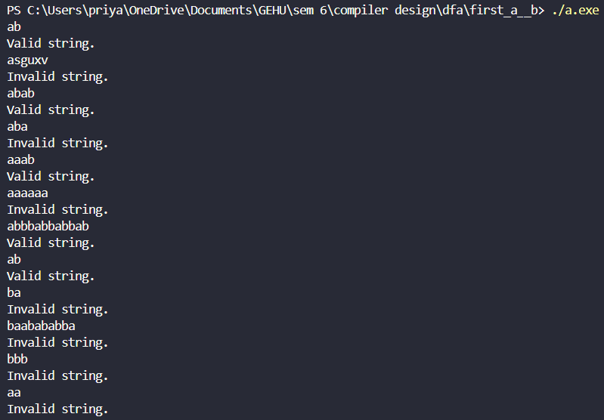

**Output 14**

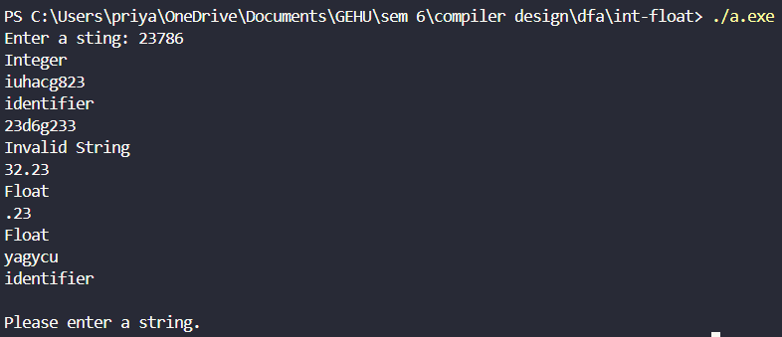

**Output 13**

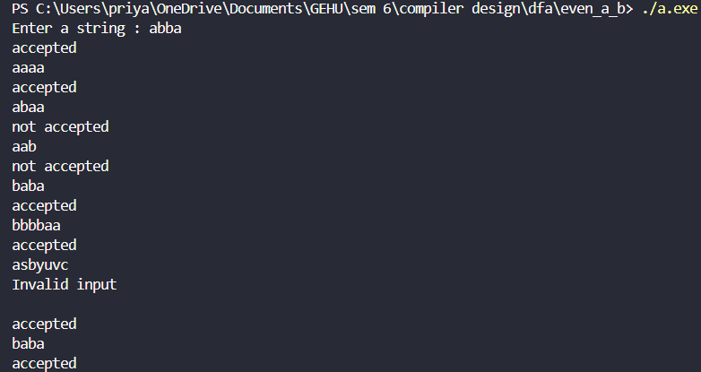

**Output 12**

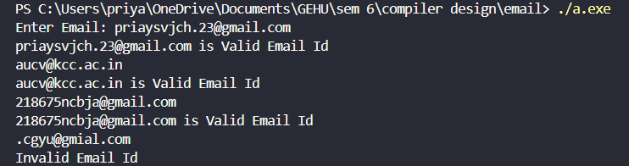

**Output 11**

**Input.html**

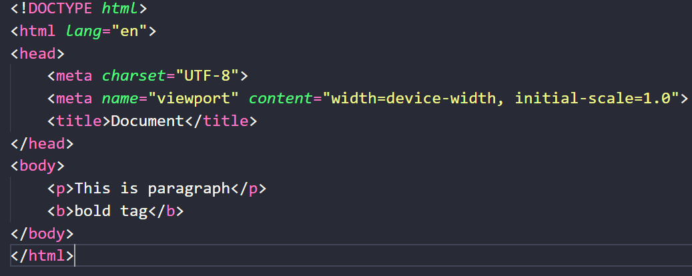

**Output.txt**

